LAB 4 Part 1 : Binary Tree

[CO2]

Instructions for students:
- Complete the following methods.
- You may use Java / Python to complete the tasks.
- DO NOT CREATE a separate folder for each task just follow the given template.
- If you are using JAVA, then follow the Java Template.
- If you are using PYTHON, then follow the Python Template.

NOTE:

YOU CANNOT USE ANY OTHER DATA STRUCTURE OTHER THAN ARRAY UNLESS MENTIONED IN THE QUESTION.

YOUR CODE SHOULD WORK FOR ANY VALID INPUTS.

For Python: List, Negative indexing and append()

and

For Java: Static or Instance variables

are STRICTLY prohibited

Lab Tasks: 1-5
Assignment Tasks: 6-8 (3 tasks)
Total Assignment Mark: 3*5=15

Lab Task 0: Basics of Binary Tree
This is an intro task & there isn’t any driver code for this
- For java, create a separate folder for this task and follow the instructions.
- For Python, create a separate colab/ipynb/py file and follow the instructions.
- Design a TreeNode class.
  - Declare three instance variables, one called elem (Object data type for java), one called left (TreeNode datatype) and another called right (TreeNode datatype).
  - Write a constructor that has only one parameter (Object type for Java) and assigns the parameter value to the elem instance variable.
- Design a Tester class (for java) / Design another code cell (for python)
- Create 6 different objects of TreeNode class. Assign values as shown in the illustration.  - Variable names should be: n1, n2, n3, n4, n5, n6.  - Connect the 6 TreeNodes as shown in the illustration which will form a binary tree. Here n1 will be the root of the tree.  Now, execute the lines given below and try to understand the output. You may need pen & paper.  If there are errors, try to figure out why that error occurred and how to fix it.  Note: Java & Python output might not always be the same. |  |  | 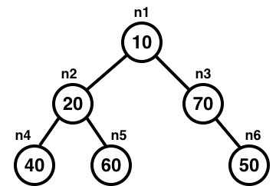
JAVA |  |  | PYTHON
System.out.println( n1.left ); |  |  | print( n1.left )
System.out.println( n3.right.elem ); |  |  | print( n3.right.elem )
TreeNode x = n2.left;  System.out.println( n1.elem + x.elem ); |  |  | x = n2.left  print( x.elem + n6.elem )
x = new TreeNode(80);  n3.left = x;  System.out.println(n1.right.left.elem); |  |  | x = TreeNode(80)  n3.left = x  print(n1.right.left.elem)
System.out.println(n1.left.right + n5.left); |  |  | print(n1.left.right + n5.left)
n1.left.right = null;  System.out.println(n1.left.right.elem) |  |  | n1.left.right = None;  print(n1.left.right.elem)

LAB TASKS

Basic Traversal:
  - Given the root of a binary tree, print the tree pre-order.
Sample Given Tree | Sample Output
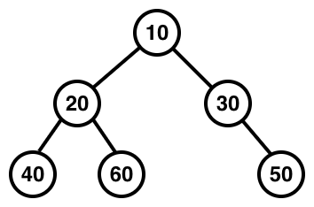 | 10 20 40 60 30 50
  - Given the root of a binary tree, print the tree post-order and the levels of each node. The level of the root is 0. You can use a helper.
Sample Given Tree | Sample Output
40:2
60:2
20:1
50:2
30:1
10:0
  - Given the root of a binary tree, print the tree in-order and the levels of each node only if the levels are even. The level of the root is 0.
Sample Given Tree | Sample Output
40:2
60:2
10:0
50:2
The 3 tasks above should give you a general idea about how traversing a tree works. Try to understand why the root was printed at the very beginning in 1.1 and at the very end in 1.2. You can simulate the recursive calls using pen and paper.

Given the root of a binary tree, return the total number of nodes in that tree.
Sample Given Tree | Sample Returned Value
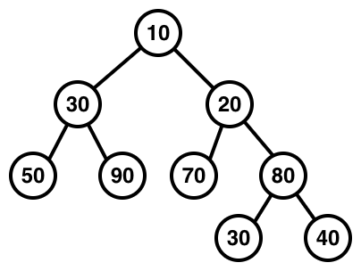 | 9
- Summation of the tree:
  - Given the root of a binary tree, return the summation of nodes in that tree. (You won’t need helper function)
Sample Given Tree | Sample Output
 | 420
  - Given the root of a binary tree, print the summation of nodes in that tree. (think how to re-use 3.1 and try to understand the difference)
Sample Given Tree | Sample Returned Value
Same as above sample | Same as above sample

- Given the root of a binary tree, print all the leaf nodes of the tree.
Sample Given Tree | Sample Output
 | 50 90 70 30 40
- Given the root of a binary tree, return the max of all nodes.
Sample Given Tree | Sample Returned Value
 | 90

ASSIGNMENT TASKS

Subtraction of Nodes:
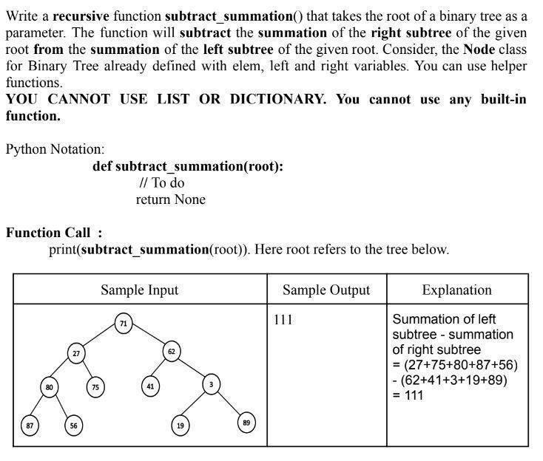

more tasks on the next page>>

Difference of Level Sum:
Given a Binary Tree, Write a function that finds the difference between sum of all nodes present at odd and even levels in a binary tree, i.e. sum of all odd level nodes - sum of all even level nodes.
Sample Input: | Sample Output | Explanation
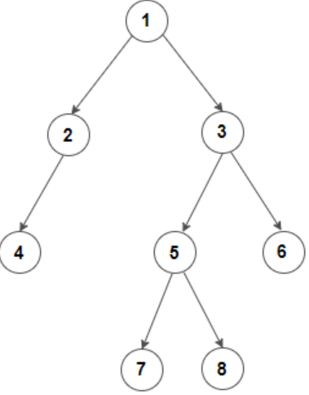 | 4 | -1+2+3-4-5-6+7+8 = 4

more task on the next page>>
- Swap Children Nodes:
